Emory University Young Artist Piano Competition
2022 Judging Panel
Scott Holden, Brigham Young University
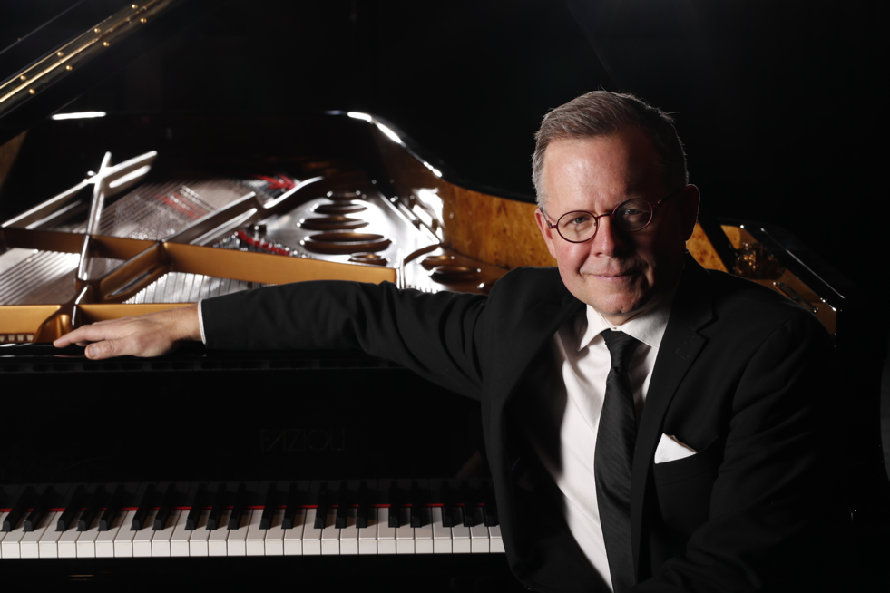
A solo pianist, champion collaborator, devoted teacher and adjudicator, Scott Holden’s dedication to the art and study of pianism is prevalent across the scope of his work. Holden debuted in Carnegie Hall after winning first prize in the 1996 Leschetizky New York Debut Piano Competition. He has performed in over forty states including at The Kennedy Center and Alice Tully Hall, throughout Europe, and in multiple Asian countries. He has been broadcast on NPR, NBC, CBC, as well as numerous local networks. His enthusiastic support of contemporary music has led to a variety of premieres, including William Wallace’s Second Piano Concerto with Keith Lockhart and the Utah Symphony of which The Salt Lake Tribune wrote, “Mr. Holden secured the stage in a virtuosic performance…We were torn between examining every new note passing by our ears, and Holden’s pianistic acrobatics. It was a wonderful dilemma.” Recent concerts have brought him across the country ranging from Alaska to New York, as well as in China, Singapore, Vietnam, and Europe. Holden returned to Carnegie Hall to play a solo recital in 2018, featuring multiple world premieres included on his newest solo CD “the Unknown Galaxy.” Fanfare praised the album: “he brings it off with excellence, mastering everything…. It’s safe to say that there is no other piano disc quite like this one.” His CD, Beyond Vernon Duke, was given the highest five-star rating stating: “Holden exhibits profoundly musical readings with obvious commitment and great attention to detail.” Holden has recorded for Parma, Bridge, Tantara and NAXOS Records.
Holden’s students have been prizewinners in numerous competitions, including top prizes at MTNA and the Gina Bachauer. His students are regularly accepted to the leading graduate programs in the nation. He travels extensively to adjudicate and give master classes at festivals and pedagogy workshops and has contributed to various publications, including both volumes of “The Pianist’s Craft”. He frequently posts piano tutorial videos on his Youtube channel, “Piano Think.”
Holden holds degrees from the University of Michigan (BM), The Juilliard School (MM), and The Manhattan School of Music (DMA). He studied at The Liszt Academy in Budapest as a Fulbright Scholar. He currently chairs the Keyboard Studies department at Brigham Young University and is a faculty member at Summer Performing Arts with Juilliard in Geneva, Switzerland.
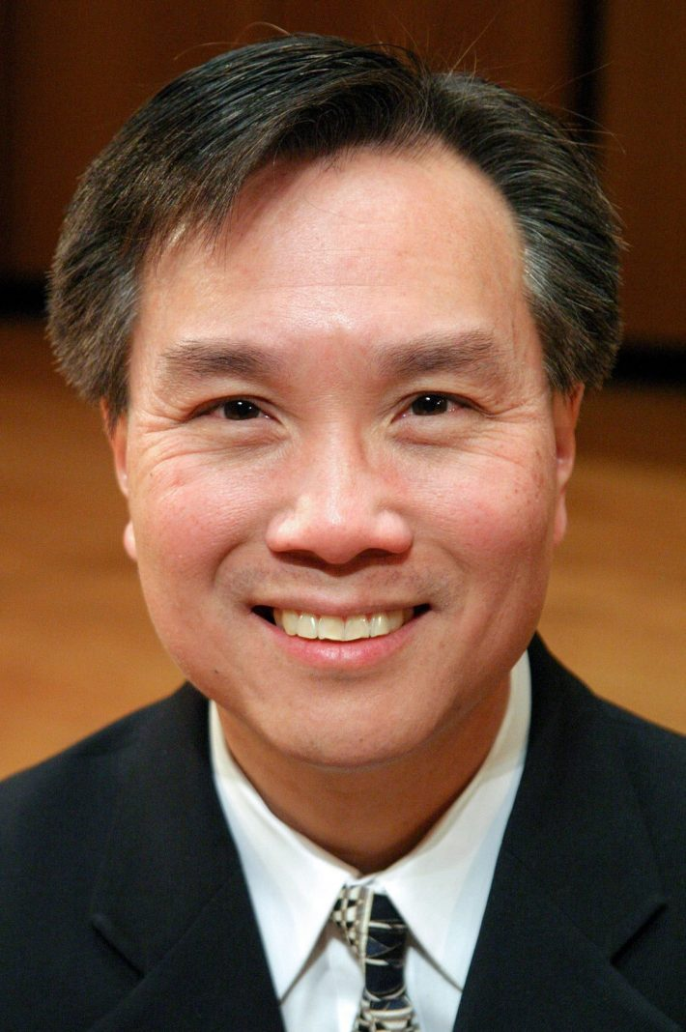
Alan Chow, Eastman School of Music
A Steinway Artist, Alan Chow has performed to critical acclaim in recital and in concert in such major venues as New York’s Lincoln Center and Merkin Hall and Chicago’s Symphony Center and Ravinia and with orchestras in the United States and Asia, included concerto performances with the National, Pan Asian, Utah, Oakland, Kansas City, and Omaha Symphonies and the Hong Kong, Shanghai, and Tulsa Philharmonics. Chow won First Prize at the Concert Artists Guild International Competition and the Silver Medal and Audience Favorite Prize at the Gina Bachauer International Piano Competition, and was formerly a member of the artist faculty at Northwestern University’s Bienen School of Music.
As a chamber musician, he has collaborated with the America, Pacifica, and Miami String quartets and been a guest artist at numerous festivals. Chow regularly tours Asia with performances in Japan, Hong Kong, Taiwan, Singapore, and China, where he also presented master classes and lectures at major conservatories. In addition, he appears in recital in the Cheng-Chow Trio with pianists Angela Cheng and his twin brother Alvin.
Chow has given master classes throughout North America and Asia at conservatories, universities, and summer festivals and is active as a juror for many piano competitions. He has served as guest professor at the Central Conservatory in Beijing, honored visiting professor at the Shenyang Conservatory, and Visiting Associate Professor at Oberlin Conservatory. His former and current students have been winners in international piano competitions.
Chow’s awards also include First Prize in the UCLA and Palm Beach Invitational International piano competitions, and he was a prizewinner in the William Kapell International Piano Competition.
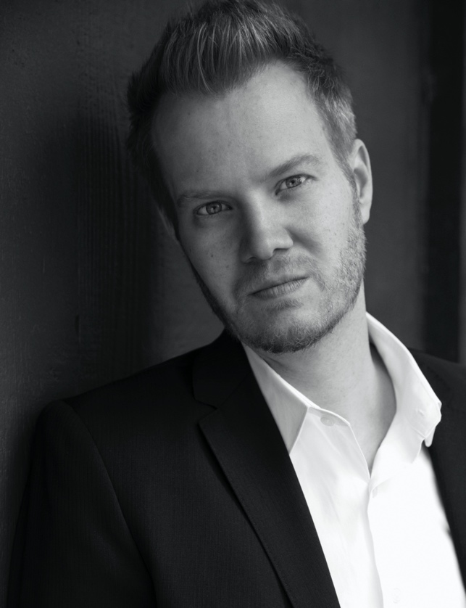
Aaron Stampfl, Colorado Christian University
Pianist Dr. Aaron Stampfl maintains an active solo and chamber concert schedule and has appeared at the Chicago Cultural Center and Weill Hall at Carnegie Hall. As a chamber artist, he performs regularly in a wide range of ensembles and genres. Dr. Stampfl has performed with renowned operatic tenor Lawrence Brownlee and Tony Award winning soul singer Heather Headley. He frequently collaborates with pianist Elena Cholakova, most recently performing the four-hand version of Stravinsky’s “Rite of Spring” at Emory University and John Brown University.
An ardent Lisztian, Dr. Stampfl is a lifetime member of the American Liszt Society, frequently performing for Chicago/Midwest Chapter concerts as well as the national festival in 2017. His research has explored the inspiration for Franz Liszt’s “Italie” in his doctoral dissertation “Interpreting the Extra-Musical Associations of Liszt’s Deuxiéme Année: Italie.”
A multi-genre performer, Dr. Stampfl was a member of the Chicago-based indie-pop band Ultra Sonic Edukators. USE recorded under the direction of Brian Bell of the Grammy winning rock band Weezer and their release on YMA records earned them recognition from Rolling Stone Magazine as one of the best bands on MySpace. Among the many bands in which Dr. Stampfl has performed, he has shared the stage with acts such as Sleeping At Last, The Fray, Gregg Allman, and Local H.
Dr. Stampfl currently serves as coordinator of keyboard studies of piano at Colorado Christian University. He has formerly taught at DePaul University, Roosevelt University, and Wheaton College in Chicago.
Dr. Stampfl completed a doctorate in music at Northwestern University, studying piano with Alan Chow and Sylvia Wang. He completed his undergraduate studies at the Wheaton College Conservatory of Music under the tutelage of Daniel Paul Horn. He studied piano and chamber music with Shigeo Neriki, Evelyn Brancart, and János Starker at Indiana University, receiving a master’s degree and performance diploma.
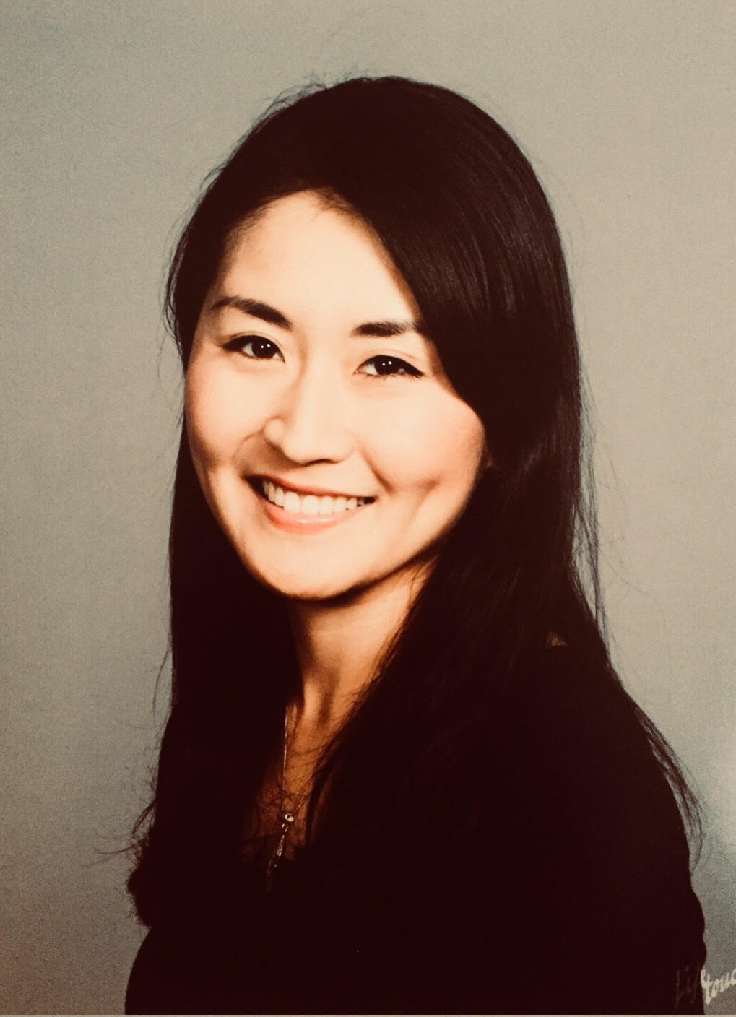
Eugenia Jeong, University of Chicago
Eugenia Jeong serves as Director of the Piano Program at the University of Chicago. She has performed across North America, Europe, and Asia in venues ranging from the Weill Recital Hall at Carnegie Hall, Chicago’s Symphony Center, Beneroya Hall in Seattle, Banff Center for Arts and Creativity, and Washington D.C.’s Millennium Stage at the Kennedy Center for the Arts, to auditoriums in Bangalore, India, Sde Boker, Israel, and South Korea. She has reached diverse audiences ranging from the Chicago Cultural Center’s regular attendees to kindergarten children in rural parts of Eastern Washington state. Equally at home as a chamber musician, she regularly collaborates with artist-faculty in the Chicago area and beyond.

Eugenia holds a Doctorate of Musical Arts degree in Piano Performance from Northwestern University with departmental program honors. Her doctoral dissertation, “Reinterpreting the Classical Music Market Crisis: An Opportunity to Reimagine Creative Presentations,” explores how conservatory-trained musicians can rethink standard concert traditions to engage broader audiences. Prior to her studies at Northwestern, she received a Bachelor of Music degree from the Eastman School of Music. Her musical mentors include Nelita True, James Giles, Willard Schultz, Golda Tatz, and Alon Goldstein. Dedicated to the performance of new music, she currently serves on the board of New Music Chicago.

